# IPL Assignment

**Simple query**

1. display all players playerid, player name and experience

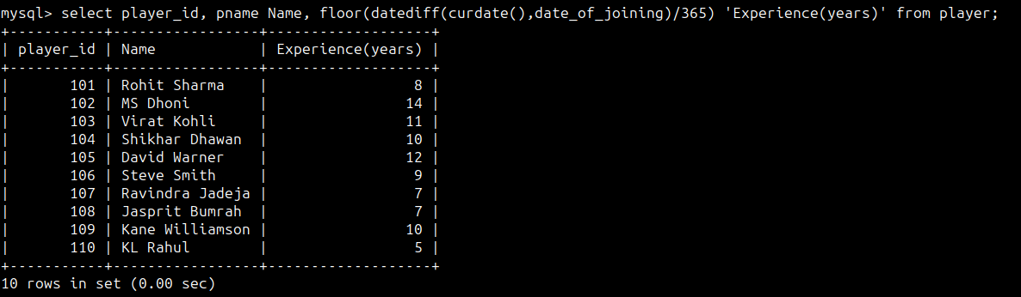

2. display all player with experience > 9 years

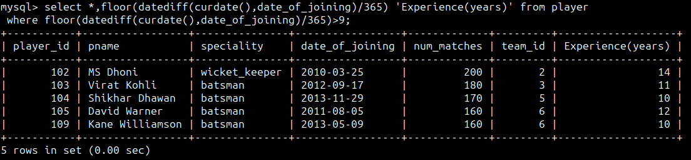

3. display all players joined in March month, any year

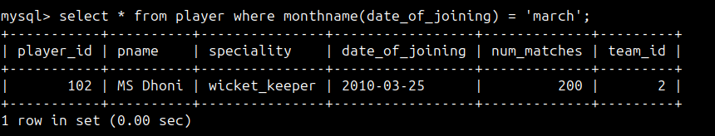

4. display all players joined in March 2010

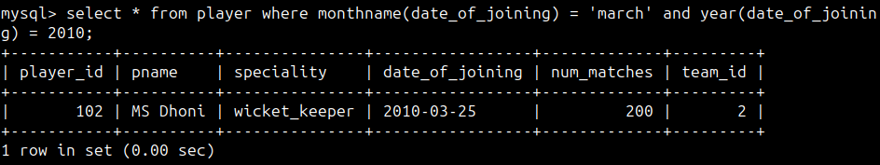

5. display all player with number of matches played are either 150 or 170 or 180

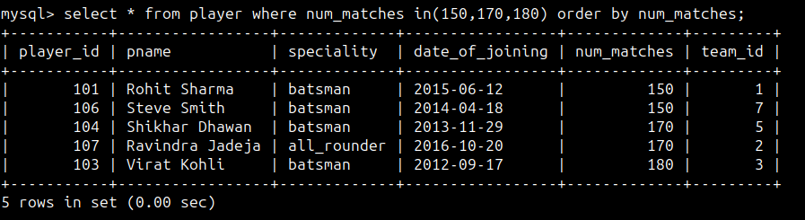

6. display all players who are either batsman, bowler

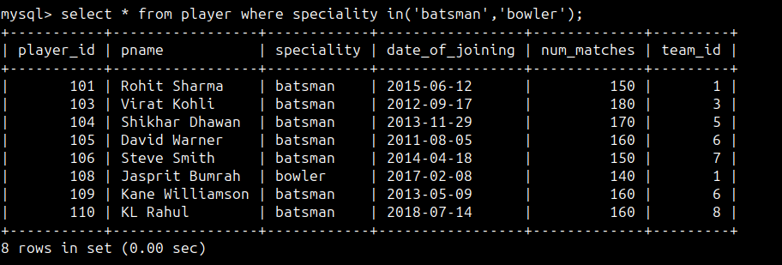

7. display all players who joined in year 2013 or 2015 or 2018

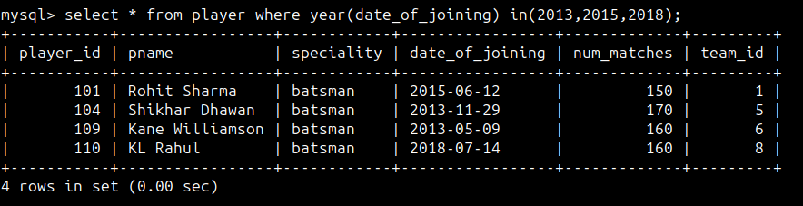

**Nested query**

1. list all player who plays in Rohit Sharma’s team

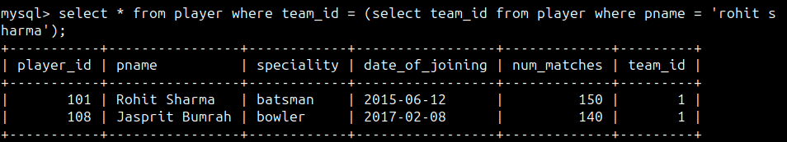

2. list all players who played match on 2022-04-07

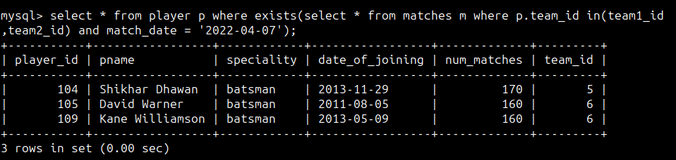

3. list all matches in which man of the match is from team1

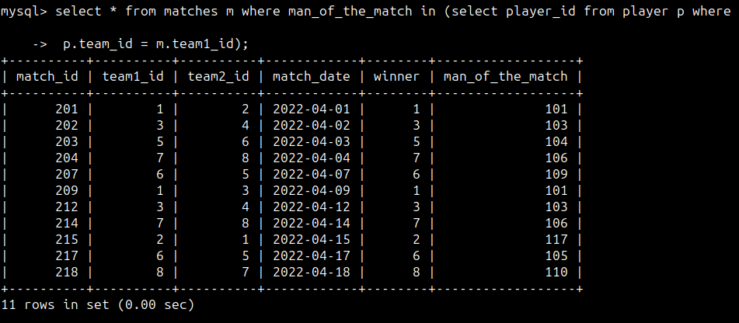

4. list all matches in which man of the match is from team2

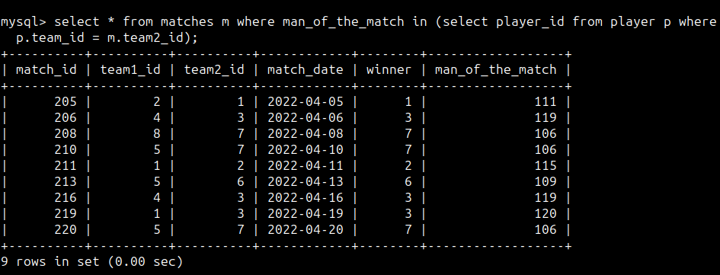

5. list all matches in which csk team win.

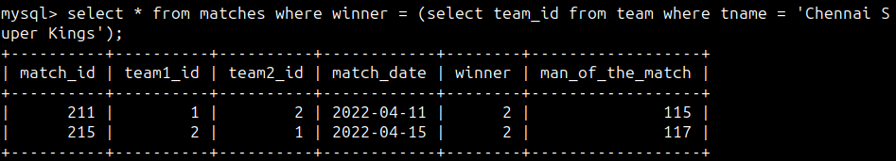

6. list all matches in which either csk or rcb team won the match

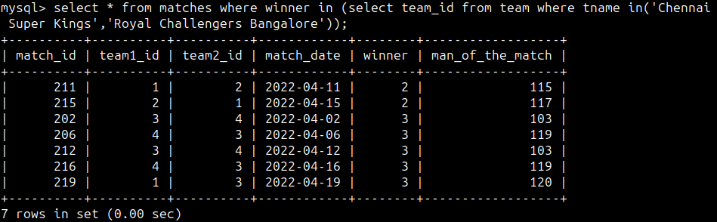

7. list all teams who one at least one match

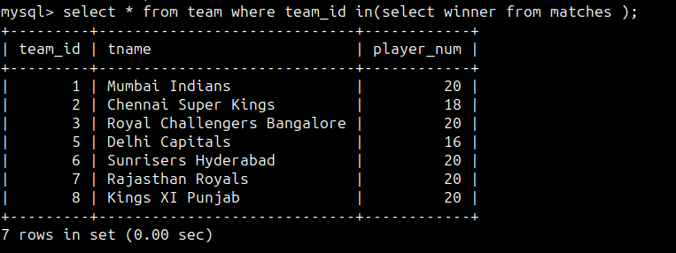

8. list all teams who does played any match

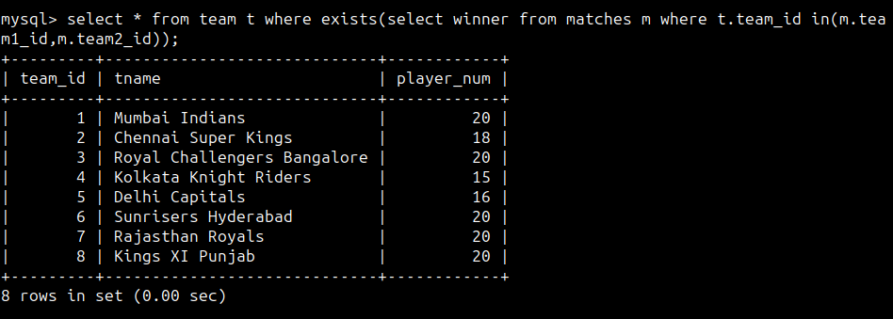

9. list all team name, in which no players are there

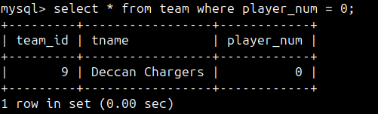

10. list all players who are in dhoni’s team

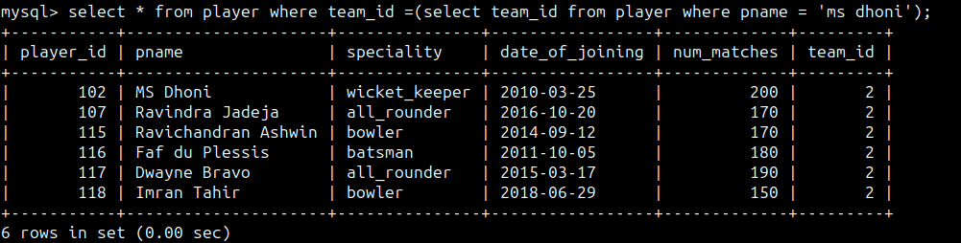

11. list all players who are in either dhoni’s or virat’s team

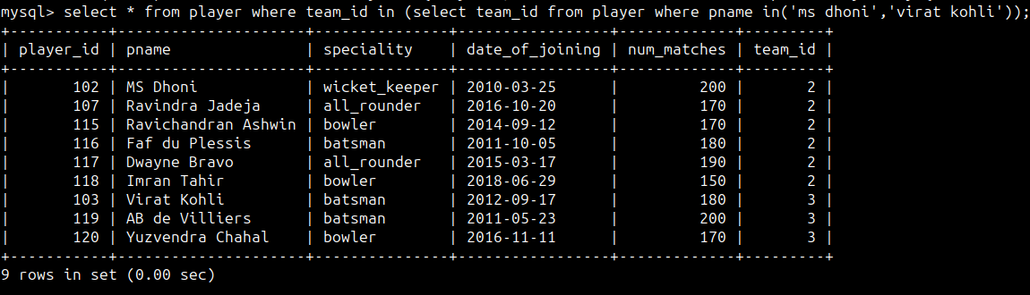

12. find all team names who one more than 3 matches

